Objective
The goal for this exercise is to illustrate total owner occupancy within each North Carolina census tract. We will focus on examining total values only. By using the entire state as a frame of reference, we should be able to notice what counties (or portions of counties) have high, medium, and low values of total owner occupancy.

Skills
After completing this exercise, the user should be familiar with the ArcMap and ArcCatalog interfaces. Basic GIS operations such as adding data for display, modifying symbology, and creating a map layout with map elements (legend, scale bar, north arrow, etc.) will also be introduced.

Data
The data used for this exercise includes North Carolina census tract boundaries and North Carolina county boundaries. Data regarding NC census tracts comes from the US Census Bureau (census.gov). NC counties data comes from the NC Department of Transportation (ncdot.org). The geographic boundary data used in this exercise can also be downloaded from NC One Map (nconemap.com) – a useful site to download NC data for free.

The GIS Project

1. Open ArcCatalog. Navigate to the Map2 folder to verify the data is present. We will be using two files for this exercise – NCCounties.shp and NCTracts_demographics.shp. 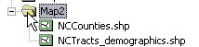

2. In ArcCatalog, open ArcMap. Click the launch ArcMap icon. The ArcMap program should begin to startup.

3. When the program loads, a starting window in ArcMap will appear. Select Start using ArcMap with A new empty map.
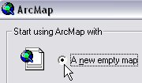

4. Add data to the project. Click the Add Data icon. In the Add Data window, navigate to the files that will be used for this project. Add NCCounties.shp and NCTracts_demographics.shp (they can be added at the same time by clicking and dragging the mouse over both files). Click Add. The files should now be viewable in the map display window.

5. Optional: View Attribute Tables. For each file, right-click the file name and select Open Attribute Table. The attribute table displays information about the file. See illustration below. Close the table(s).

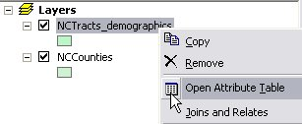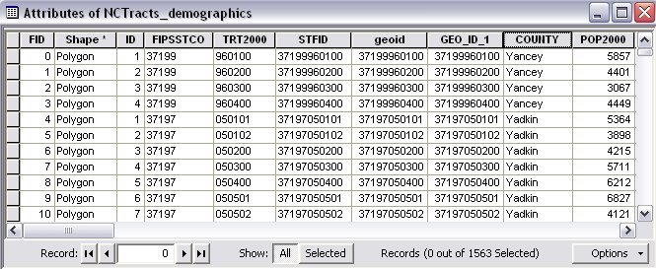

6. Change the symbology for NCCounties. Single-click the color box under the file name NCCounties. The Symbol Selector window should open. Change the Fill Color to No Color (hollow). Change the Outline Color to Arctic White (or your preference). Use the illustration below for reference. Click OK.

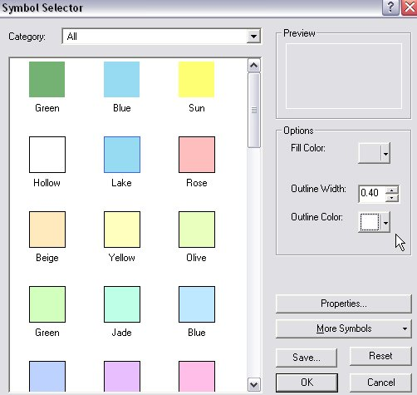

7. Change the symbology for NCTracts_demographics. Right-click the file name and select Properties. The Layer Properties window should open. In the Layer Properties window, click the Symbology tab. On the left-side menu, click Quantities > Graduated Colors. New options should be available to choose from. In the Fields section, change the Value field by clicking the drop-down menu. Choose OWNER_OCC. In the Classification section, click Classify (a new window will pop-up). Change the Method to Quantile in the drop-down menu. Click OK. The Color Ramp can also be changed in the Layer Properties window. Use the illustration below for reference. Click OK.

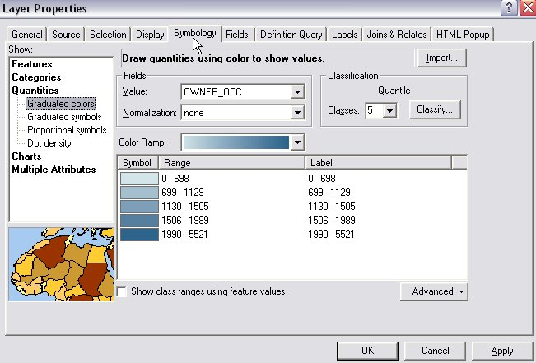

8. Rearrange layers for viewing. The NCCounties layer should be ordered above the NCTracts_demographics layer in the Table of Contents window (Layers). If it is not already, click and drag NCCounties above NCTracts_demographics and drop. The map display window should show all counties and all tracts (with color values).

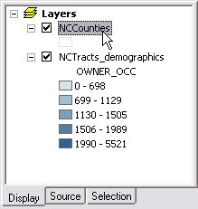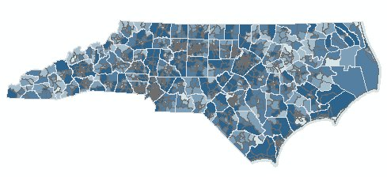

9. Work in Layout View. Switch to the Layout View by clicking View in the top toolbar and select Layout View. The display will change to a layout view (as if the graphics are on paper).

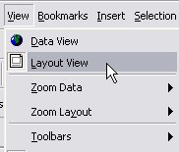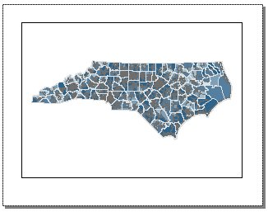

10. Add map elements to the layout view. The map elements include a title, legend, north arrow, and scale bar. To add these to the map, click Insert in the top toolbar and select from the drop-down menu. These can be modified and rearranged for customization on the layout view.

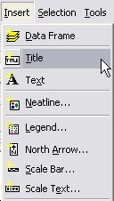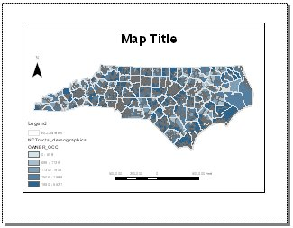

11. After all map elements and layout view options have been complete, export the file as a PDF for print, email, etc. Click File from the top toolbar and select Export Map. Navigate to the appropriate folder and save PDF.

