Objective
To use an online batch geocoding tool to learn how to quickly georeference addresses and place address points on a map.

Data
counties.shp, addresses_for_geocoding.xls

The GIS Project

1. Open the addresses_for_geocoding spreadsheet, which contains address we would like to see mapped. These have been parsed into street address, city, state and zip already, but you may have to manually do this is the future.

2. Open a web browser like Firefox and go to http://www.batchgeocode.com.

3. In Step 1, keep the default of Tab Delimited. In Step 2, paste your addresses in the box from the Excel file.
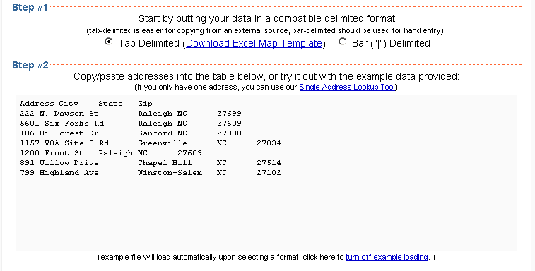

4. Click the Validate Source button is step 3. The geocoding tool should find 4 columns and 7 rows.

5. In Step 4, the fields should be automatically populated based on your header names. Make sure it looks like this:
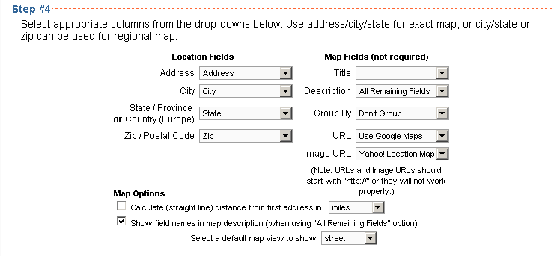

6. Click the Run Geocoder button. Your geocoding points are displayed on the online map viewer, and in the geocoding results, you can see that lat/long coordinates were added to each of the points. Copy these two columns and paste them back to your Excel spreadsheet. Save the spreadsheet.
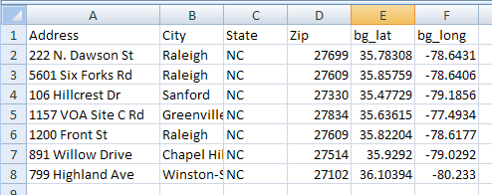

7. Open ArcMap. Click the Add Data () button, and browse to the Excel Spreadsheet. Choose to add Sheet1$.
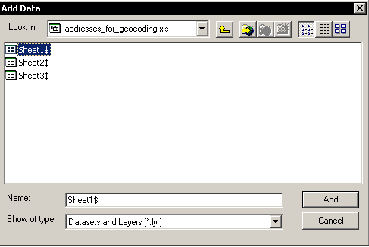

8. Right click on Sheet 1$ and choose Display XY Data. For X Field, choose bg_long. For Y Field, choose bg_lat. In the Coordinate System of Input Coordinates box, click the Edit button, click Select, double click Geographic Coordinate Systems, double click North America and finally choose North American Datum 1983.prj.
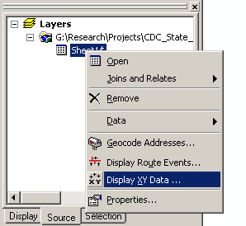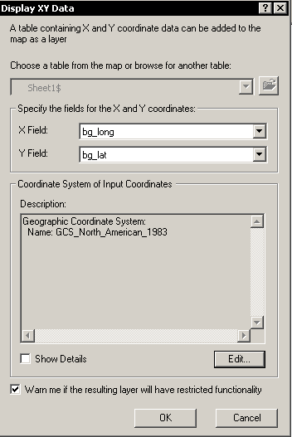

9. Click Ok and you will see a warning about reduced functionality. This is fine, so click OK. Your data is now geocoded. Use the Add Data () button to overlay the counties layer to make sure everything looks ok. The counties look warped. This is because they are in a projected coordinate system, and the data frame is in a geographic coordinate system. To change this, right click anywhere and choose Data Frame properties. Choose the Coordinate System tab. Click Import, and import the coordinate system from the counties.shp shapefile. Click ok.
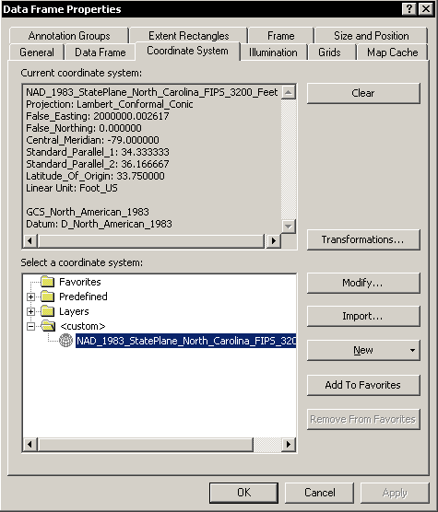

10. The last step is to turn your displayed points into real data that you can save and manipulate. Right click on the Sheet1$ Events layer and choose Data > Export data. Choose to export All features, and use the same coordinate system as the data frame. You will have to change this setting. Save this new shapefile into your folder, with a name of your choosing.

11. Add a legend, scale bar, title and north arrow to create a layout for your points.

