Objectives
The main goal for this exercise is obtain point level data for EPA regulated sites for North Carolina and spatially join these points to NC Census Tract geography. Once joined to tracts the counts for the number of facilities per tract can be displayed in a meaningful fashion. A choropleth map of NC census tracts illustrating the counts of EPA regulated sites will be created.

Skills
After completing this exercise, you will be familiar with: spatial selections and the polygon to point spatial join. You will also be introduced to concepts related to the display of quantitative data and be introduced to an easy free online color scheme tool: color brewer

Data
The geographic boundary data used for this exercise includes a polygon shapefile for North Carolina census tract boundaries (downloaded from NC One Map nconemap.com) and a point shapefile (downloaded from Data.gov). The Data are located here:
Map_Making_Sessions\Transforming_session\Map2\session2_map2data

GEODATA_Shapefile_JUL_2009.shp- Points of all EPA regulated facilities in the US
NCTractBoundaries.shp- US Census 2000 tract boundaries for NC

Both of these shapefiles are vector representations of data, there is a point representation (GEODATA_Shapefile_JUL_2009.shp) and a polygon representation (NCTractBoundaries.shp).

The GIS Project

- Open ArcCatalog. Navigate to Map_Making_Sessions\Transforming_session\Map2\session2_map2data folder to verify the data is present. The two shapefiles to be used will be in this folder.
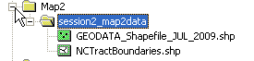

- In ArcCatalog, open ArcMap. Click the launch ArcMap icon. The ArcMap program should begin to startup.

- When the program loads, a starting window in ArcMap will appear. Select Start using ArcMap with A new empty map.
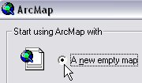

- Get started by setting up your data frame properties. In ArcMap you may work with single or multiple data frames. In this exercise we will work with one data frame. Right click on your dataframe located in your table of contents (the default name is “layers”)
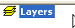

- Select the properties tab located at the bottom of the dropdown menu. The properties window will open the data frame properties window.

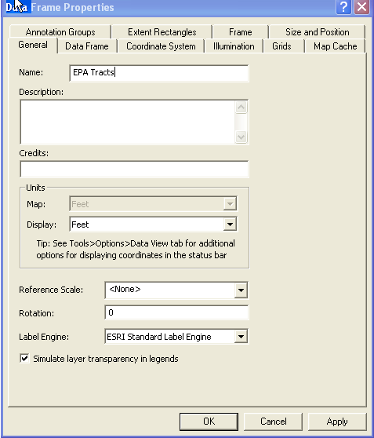

- First select the General tab; rename this layer by typing in “NC County Map” for name.
- Next you will A Select the coordinate system you will set up the projection system for the data frame. Select the coordinate system tab; you will notice there is no projection for your data frame.
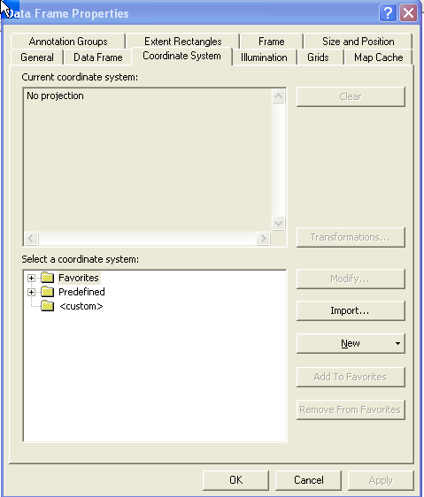
- Set the projection for the data frame. You will select a widely used and accepted predefined North Carolina coordinate system for the dataframe. Expand the following folders to select a coordinate system:
Predefined
Projected coordinate systems
State plane system
NAD 1983 StatePlane North Carolina FIPS 3200 (Feet)
Once you have set the coordinate system click OK. Once you have done this, any data added to the data frame that are projected in another coordinate system, or without a projection the will be projected on the fly and visualized.

- Now you are ready to add data. Use the add data icon
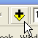

When prompted navigate to your folder; this is a good time to establish a folder connection using the connect to folder icon:
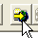
Once connected you can quickly add data to you project from connected folders.

- First, add NCTractBoundaries.shp. The geographic boundaries file should be viewable in the map display window.

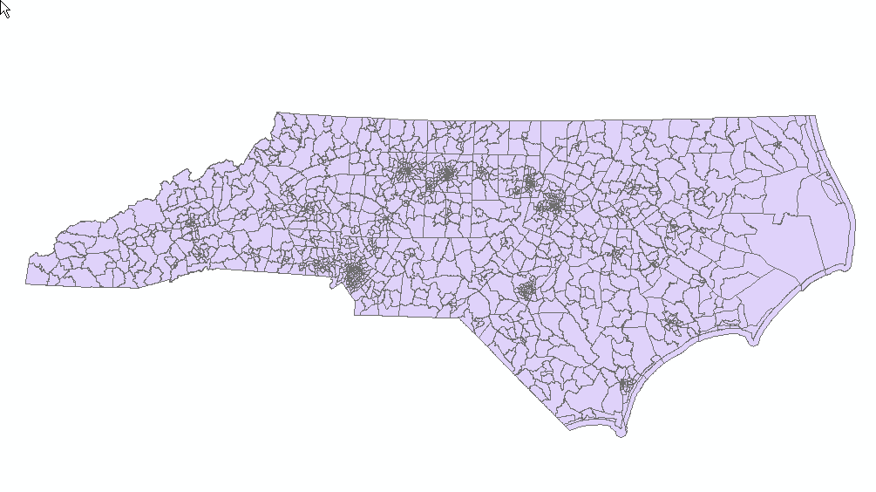
- Now add the GEODATA_Shapefile_JUL_2009.shp to your data frame, you will see that the points extend past the tract boundaries for the state. We want to make a selection of points that are located within NC, to do this you will
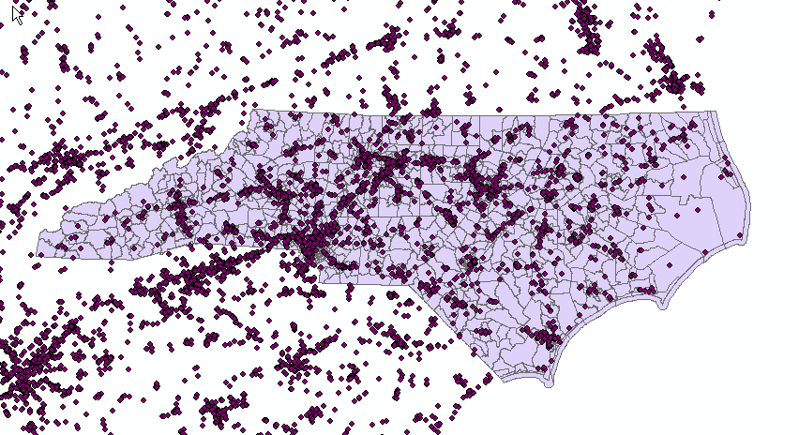

- Select by location, those points within the state tracts by clicking on the selection tab and choosing select by location.
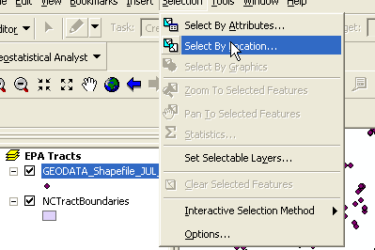
You will select features from GEODATA_Shapefile_JUL_2009.shp that are within NCTractBoundaries.shp as shown below:

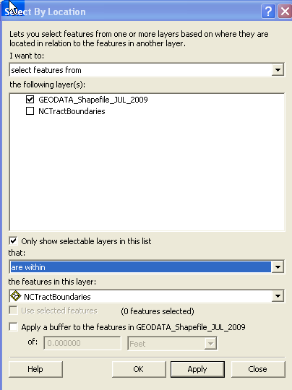

Once this is done click ok (this may take awhile- there are quite a few points).
- 6. Verify your selection- right click on GEODATA_Shapefile_JUL_2009 in your TOC and open the attribute table, at the bottom of your table you should see the following:
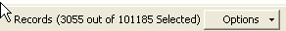
Once you have verified this number of records has been selected close the table.

- Export your selection to a new shapefile, right click on GEODATA_Shapefile_JUL_2009 in the TOC and select the data option, choosing the export data option. Make sure you choose “Use the same coordinate system as the data frame” and save you output to your data folder:
Map_Making_Sessions\Transforming_session\Map2\session2_map2data; name the resultant shapefile: NC_EPA_PTS

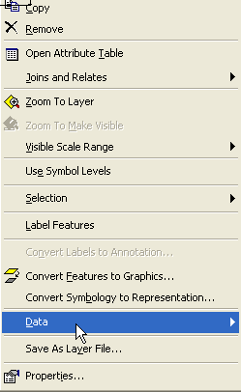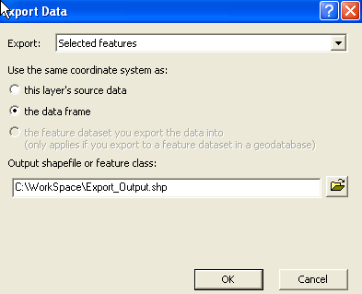

- When the export is complete add the data to your data frame
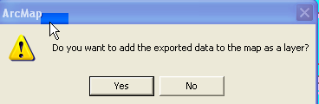
You have successfully made a spatial selection, choosing only those points within NC’s census tracts.
You can now remove the GEODATA_Shapefile_JUL_2009.shp, by right clicking on it in the TOC and selecting remove. The resulting map should look something like this:
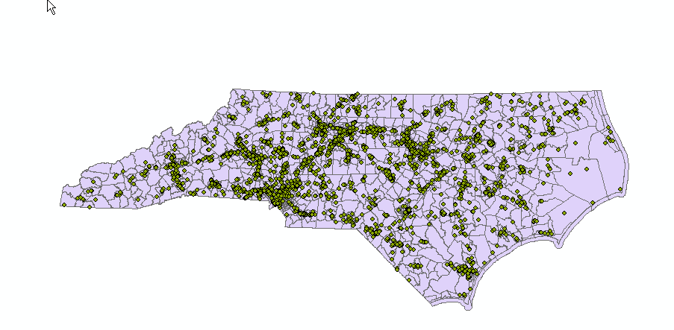

The map now displays only those EPA regulated sites within the Census 2000 Tracts for NC.

- This map can be useful, but we seek to get a count of facilities per census tract and this is accomplished with a spatial join. To do this, right click on NCTractBoundaries.shp in your TOC and select “join”.

Once you select join you will be asked “what do you want to join to this layer?” In the dropdown select: “join data from another layer based on spatial location”. The layer to join is: NC_EPA_PTS.

You will be joining points to polygons, and selecting the first option. For the “How do you want the attributes to be summarized question check “sum” this will give you a count of points in each of your tracts. Save your result in your data folder as: Tract_EPA_join_output and click ok

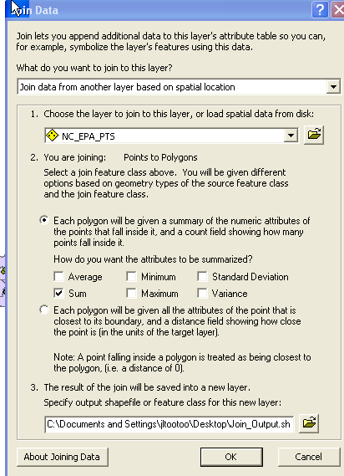

- The result shapefile will be added to you TOC, click on it and drag it below the NC_EPA_PTS.shp then right click on it and open the attribute table.
The attribute field of interest created by the join is “count” This field reflects the count of EPA regulated sites contained by each census tract.

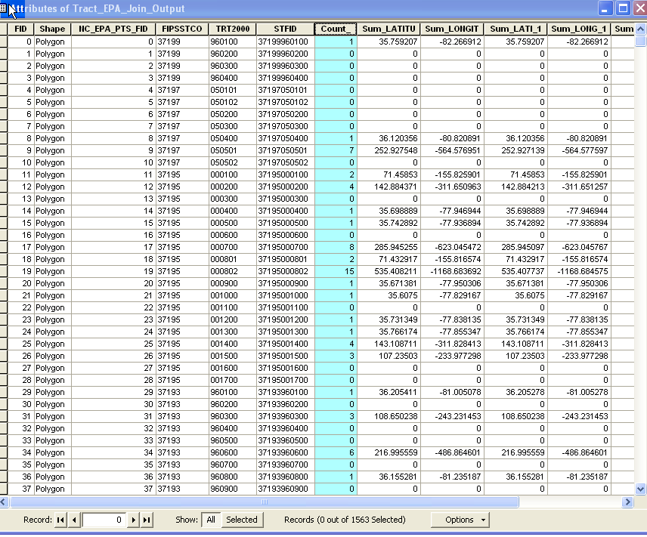

You can verify this by left clicking on the grey box to the left of the FID field to select a record (tract) taking note of the count of facilities it contains closing the table and zooming to the selection and counting the points contained in the polygon.

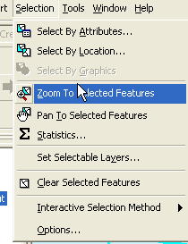

Once you have done this clear your selection and click on global extant 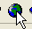

- Create a chloropleth map of counts of EPA regulated facilities by tract. With the newly joined files, choose the count field from Tract_EPA_join_output shapefile and display values with a color ramp. Right-click Tract_EPA_join_output and choose Properties. The Layer Properties window should appear. In the Layer Properties windows, navigate to the Symbology tab. In the left-hand menu, show Quantities > Graduated colors. A new menu should appear in the Layer Properties window.

- Need help with color? Take a look at: http://www.personal.psu.edu/cab38/ColorBrewer/ColorBrewer.html

- In the Fields menu, change Value to Count_ (leave Normalization as none). In Classification (a new window will appear after clicking Classify), change the Method to Quantile (then click OK). Optional: change the Color Ramp. Click OK. The Tract_EPA_join_output should be symbolized in the display window.

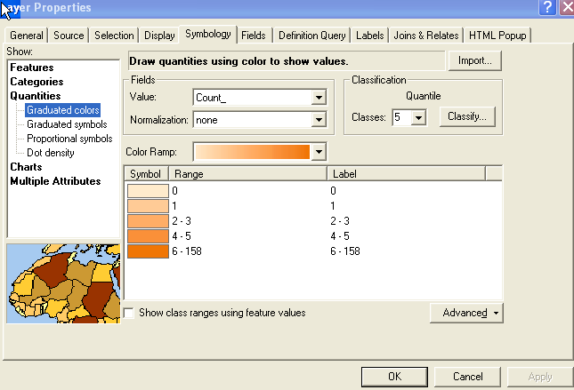

12. Optional: Change the View to Layout View and add map elements. When finished, export map as a PDF for print or email.

