Objectives
The main goal for this exercise is obtain point level data for EPA regulated sites for North Carolina and spatially join these points to NC Census Tract geography. Once joined to tracts the counts for the number of facilities per tract can be displayed in a meaningful fashion. A chloropleth map of NC census tracts illustrating the counts of EPA regulated sites will be created.

Skills
After completing this exercise, you will be familiar with: spatial selections and the polygon to point spatial join. You will also be introduced to concepts related to the display of quantitative data and be introduced to an easy free online color scheme tool: color brewer

Data
The geographic boundary data used for this exercise includes a polygon shapefile for North Carolina census tract boundaries (downloaded from NC One Map nconemap.com) and a point shapefile (downloaded from Data.gov). The Data are located in the s2-spatial-join folder

GEODATA_Shapefile_JUL_2009.shp- Points of all EPA regulated facilities in the US
NCTractBoundaries.shp- US Census 2000 tract boundaries for NC

Both of these shapefiles are vector representations of data, there is a point representation (NC_DATA_Shapefile_JUL_2009.shp) and a polygon representation (NCTractBoundaries.shp).

The GIS Project

- Open ArcCatalog. Navigate to s2-spatial-join folder to verify the data is present. The two shapefiles to be used will be in this folder.
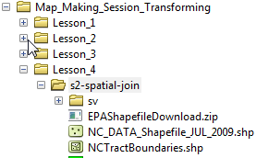

- In ArcCatalog, open ArcMap. Click the launch ArcMap icon. The ArcMap program should begin to startup.

- When the program loads, a starting window in ArcMap will appear. Select to start with a blank map

- Add data. Use the add data icon

- First, add NCTractBoundaries.shp. The geographic boundaries file should be viewable in the map display window.

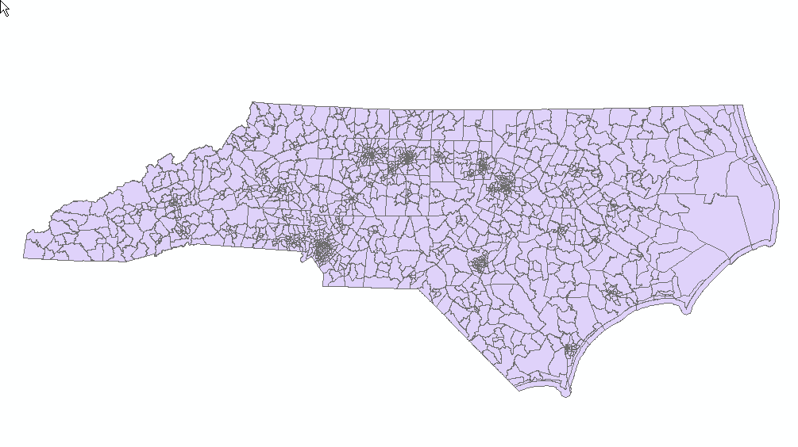
- Now add the NC_DATA_Shapefile_JUL_2009.shp to your data frame.
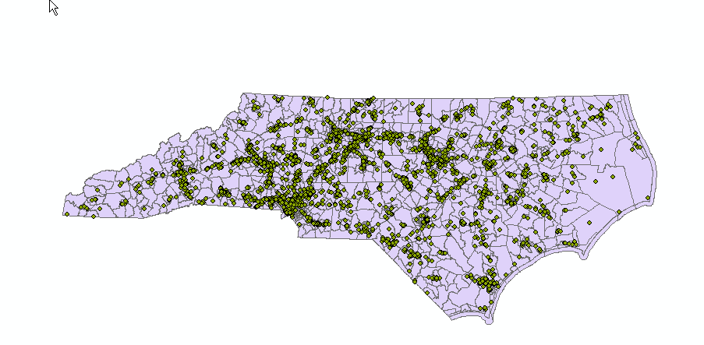

The map displays EPA regulated sites within the Census 2000 Tracts for NC.

- This map can be useful, but we seek to get a count of facilities per census tract and this is accomplished with a spatial join. To do this, right click on NCTractBoundaries.shp in your TOC and select “join”.

Once you select join you will be asked “what do you want to join to this layer?” In the dropdown select: “join data from another layer based on spatial location”. Save your result in your data folder as: Tract_EPA_join_output and click ok

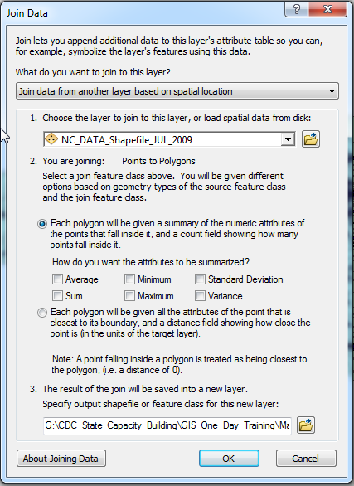

- The result shapefile will be added to you TOC. Turn off the other two layers so that you only have your new shapefile showing. Open the Attribute Table of your new shapefile. We now have a Count field.
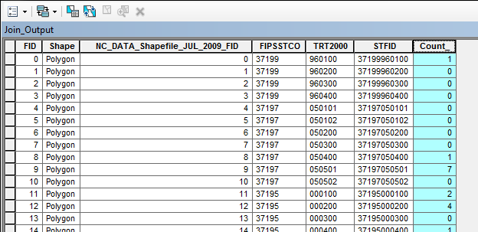

- Create a chloropleth map of counts of EPA regulated facilities by tract. Right-click Tract_EPA_join_output and choose Properties. The Layer Properties window should appear. In the Layer Properties windows, navigate to the Symbology tab. In the left-hand menu, show Quantities > Graduated colors. A new menu should appear in the Layer Properties window.

- Need help with color? Take a look at: http://www.personal.psu.edu/cab38/ColorBrewer/ColorBrewer.html

- In the Fields menu, change Value to Count_ (leave Normalization as none). In Classification (a new window will appear after clicking Classify), change the Method to Quantile (then click OK). Optional: change the Color Ramp. Click OK. The Tract_EPA_join_output should be symbolized in the display window.

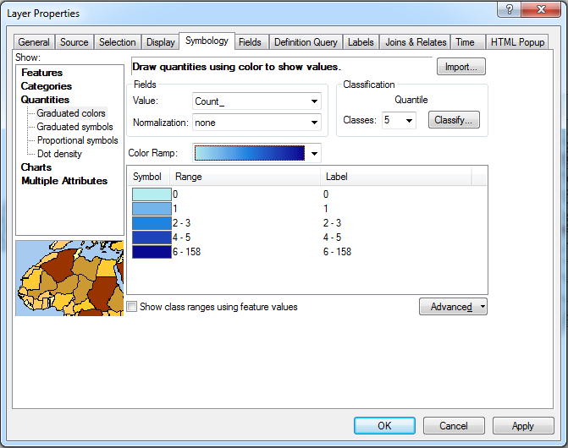

12. Change the View to Layout View and add map elements. When finished, export map as a PDF for print or email.

