Prenatal Screening for Group B Streptococcus
(Non-pigmented broth, serologic or molecular testing for identification)

Annual Review:
Name/Title | Signature | Date

Revision History:
Revision # | Control # | Changes made to document section | Author | Date
Approval Signatures:
Approved by: _______________________________ Date: __________________
Author
____________________________________________________________
Print Name and Title

Approved by: _______________________________ Date: __________________
Supervisor/Technical Specialist-Director ____________________________________________________________
Print Name and Title

Approved by: _______________________________ Date: __________________
Quality Manager
____________________________________________________________
Print Name and Title
Purpose/Principle:
The purpose of this document is to provide instructions for performing prenatal screening for Group B Streptococcus from appropriately collected vaginal/rectal specimens using non-pigmented broth enrichment with serologic or molecular testing for identification.

Scope:
This document applies to laboratory assistants, technicians and technologists within the Division of Microbiology at XXXX.

Related documents:
- Provider procedure for collection of specimens for Prenatal Screening for Group B Streptococcus - # xxxx. Note: Procedure should specify the acceptable specimen is a vaginal-rectal swab and that swabs from other sites (e.g. cervical or perianal swabs only) are not acceptable. Procedure should list acceptable type of swab and transport medium.
- Quality Control procedure for tube and plated media - # xxxx.
- Procedure for Group B Streptococcus serologic testing from broth culture - # xxxx.
- Procedure for Group B Streptococcus molecular testing from broth culture - # xxxx.
- Procedure for the identification of streptococci - # xxxx.
- Notification procedure for positive Prenatal Screening for Group B Streptococcus - # xxxx.
- Procedure for susceptibility testing of Group B Streptococcus - # xxxx.

Responsibility:
- It is the responsibility of the technical staff of the microbiology laboratory to review and assure they are familiar with the processes outlined in this document which are within their job duties.
- It is the responsibility of the technical specialist to keep this procedure updated and current with national standards/guidelines/recommendations.
- It is the responsibility of the microbiology supervisor to accurately train and assess the competency of all microbiology staff involved in performing this procedure.
- It is the responsibility of the microbiology data technologist to assure that reporting of all results is appropriate in all computer systems.
- It is the responsibility of the technical director to approve this procedure on an annual basis.

Definitions:
N/A

Equipment/Materials:
- Trans-Vag broth supplemented with 5% defibrinated sheep blood, LIM broth (or equivalent)
- Agar plates for subculture for susceptibility testing (e.g., tryptic soy agar with 5% defibrinated sheep blood, or equivalent)
3. Sterile loops
4. Incinerator
5. Incubator
6. Serologic instrumentation and/or reagents
7. Molecular instrumentation and/or reagents

Quality Control:
Follow Quality Control procedures for tube and plated media - # xxxx.
Follow Quality Control procedures for serologic testing for Group B Streptococcus - # xxxx.
Follow Quality Control procedures for molecular testing for Group B Streptococcus - # xxxx.

Safety Precautions:
Use standard precautions when performing this procedure.

Procedure: (Appendix includes one-page flowchart)
- Remove patient specimen (swab; swabs) from transport medium. Specimens should be processed within 4 days of collection. Specimens requiring more than 24 hr of transport time should be refrigerated until received and processed by the laboratory.
- Inoculate swab(s) into a recommended selective enrichment broth medium, such as Trans-Vag broth supplemented with 5% defibrinated sheep blood, LIM broth or equivalent. [Before inoculating into broth, laboratories may choose to direct plate by rolling the swab(s) on a sheep blood agar plate, NNA agar, CNA agar, other selective Streptococcus agar. If Group B Streptococcus is identified from the primary plate, report Group B streptococcus positive on the culture report. If Group B Streptococcus is not identified from the primary plate, plate should be discarded, and enriched broth processed as per protocol below and results reported out from enriched broth].
- Incubate the inoculated broth for a minimum of 18-24 hours at 35-37ºC in ambient air or 5% CO₂ or for the length of time and conditions recommended by the manufacturer. The broth should display visible turbidity as an indicator of adequate specimen collection. A clear broth after 24 hours of incubation indicates failure to obtain a proper sample and a new specimen should be requested.
- Perform serologic testing or molecular testing on the incubated broth for Group B Streptococcus.
- Report as negative for Group B Streptococcus when no Group B Streptococcus has been identified by serologic testing or molecular testing.
- If Group B Streptococcus is identified by serologic testing or molecular testing, report Group B Streptococcus positive on the report.
- If the positive specimen is from a penicillin-allergic patient at high risk for anaphylaxis, subculture the incubated broth to a sheep blood agar plate (e.g., tryptic soy agar with 5% defibrinated sheep blood, or equivalent) and incubate for a minimum of 18-24 hour at 35-37ºC in 5% CO₂.
  - Inspect and identify colonies characteristic of Group B Streptococcus (i.e., gram-positive cocci, catalase negative, narrow zone of β-hemolysis or no hemolysis) using routine laboratory identification protocols. (Refer to procedure # xxxx – Procedure for the identification of streptococci).
  - Perform susceptibilities for clindamycin and erythromycin, including inducible clindamycin resistance, using appropriate laboratory susceptibility procedures. (Refer to protocol # xxxx – Procedure for susceptibility testing of Group B Streptococcus.)
NOTE: As molecular testing may be more sensitive than culture, on occasion subcultures of broths may not recover Group B Streptococcus in order to perform susceptibility testing. In this case report “No Group B Streptococcus recovered for the performance of susceptibility testing.” The clinician may be directed to the CDC guidelines for prophylaxis of patients colonized with Group B Streptococcus for which susceptibility is unknown.

Format:
N/A

Reference:
MMWR Recomm Rep. 2010 Nov 19;59(RR-10):1-36. Prevention of perinatal group B streptococcal disease--revised guidelines from CDC, 2010. Verani JR, McGee L, Schrag SJ; Division of Bacterial Diseases, National Center for Immunization and Respiratory Diseases, Centers for Disease Control and Prevention (CDC).
Experts from the American Society for Microbiology (ASM) and the Centers for Disease Control and Prevention’s (CDC) Streptococcus Laboratory co-authored this document.*

For more GBS laboratory resources, visit http://www.cdc.gov/groupbstrep

*Collaboration does not imply HHS/CDC endorsement of ASM
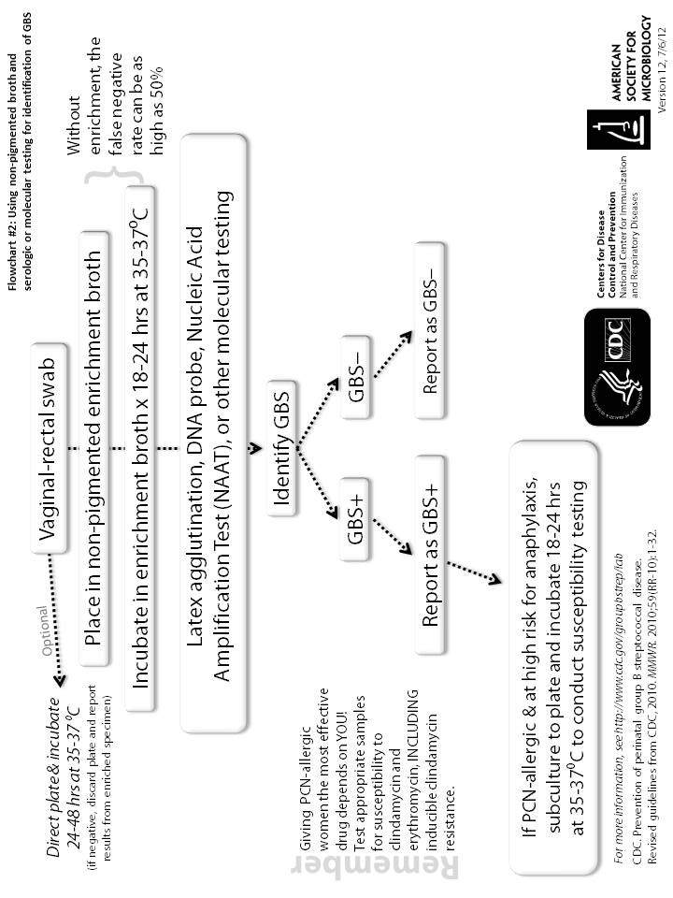
Appendix: Flow diagram for Prenatal Screening for Group B Streptococcus: Non-pigmented broth, serologic or molecular testing for identification

