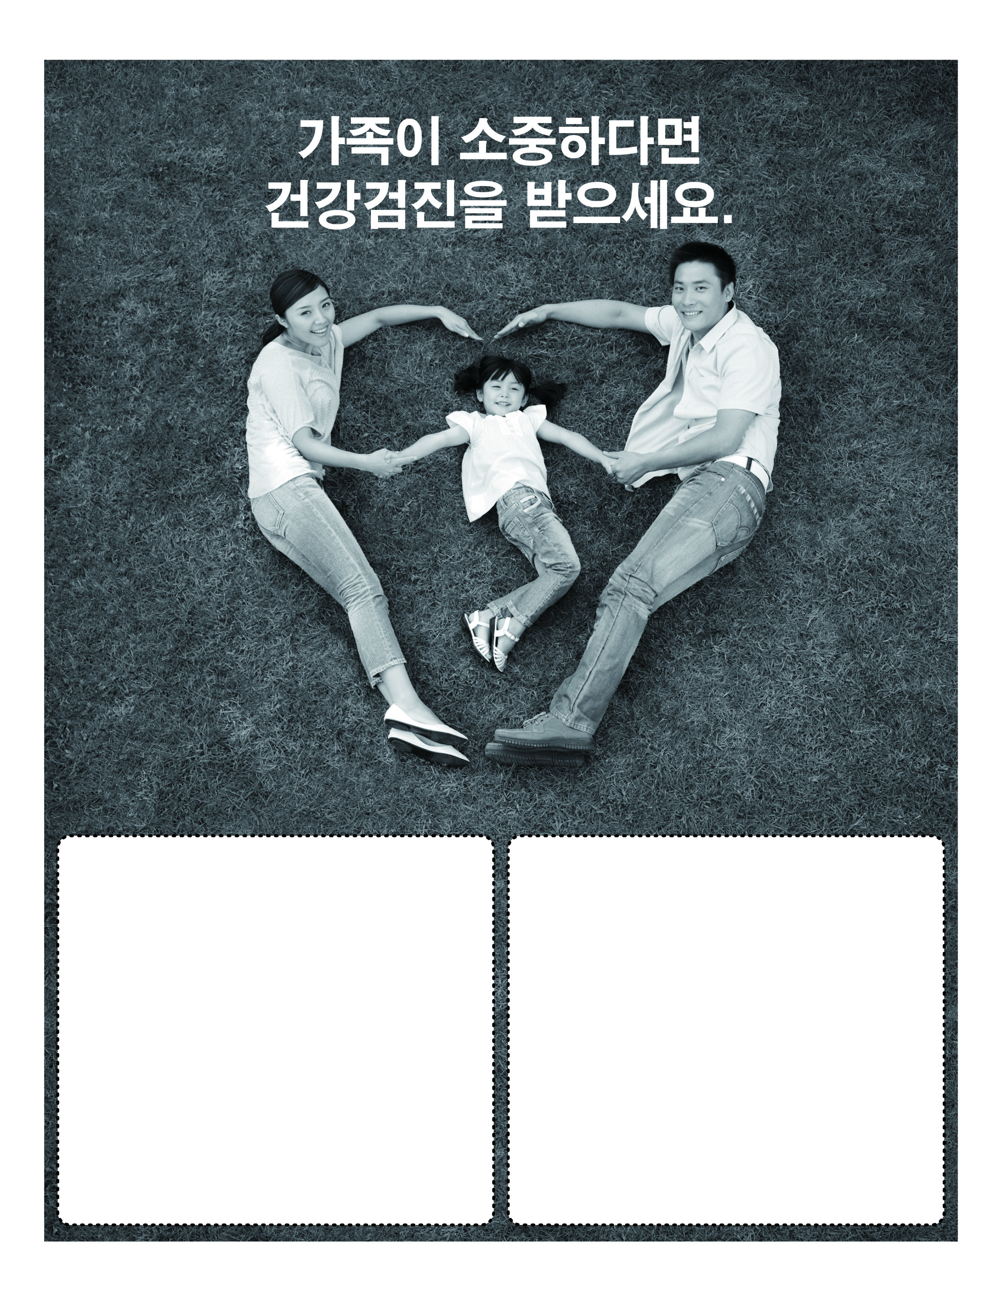
건강검진 정보
Sunday, May OO, 2014 | 10AM-3PM
Sponsoring Organization Name
100 Main Street, | City, State
Call (123) 456-7899 for
more information

