Step 1a – Open a blank Microsoft Excel 2007© spreadsheet by selecting the Microsoft button (1) at the upper, left portion of the window and then from the General tab, select the Workbook icon (2). Close the dialog box by selecting the OK button (3).
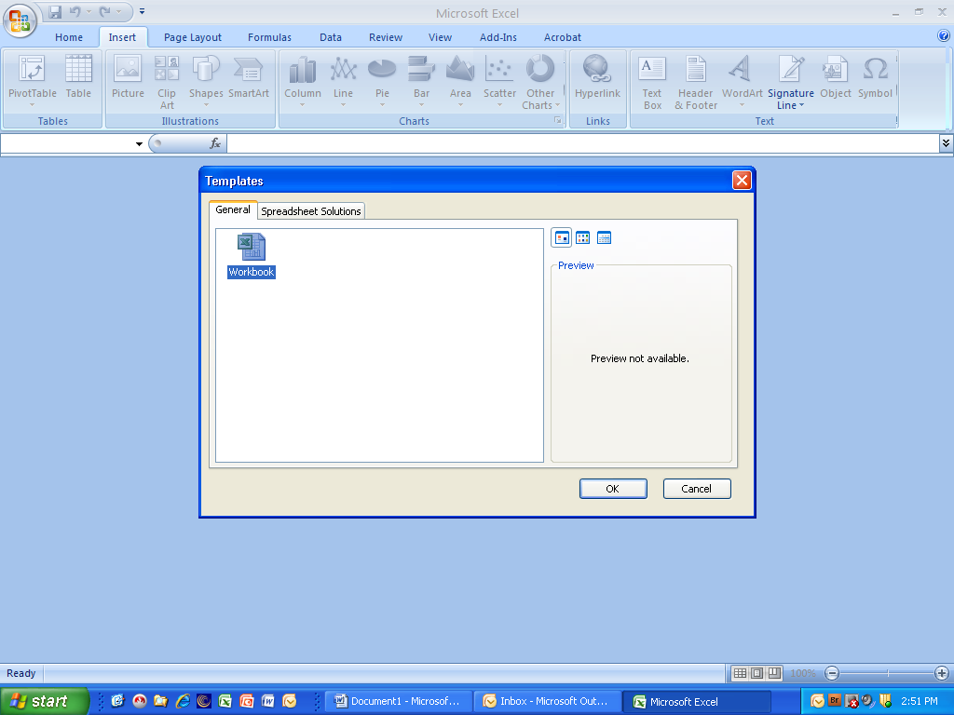
1
2
3

Step 1b - Set up the row headers with the following information:
- In cell A1, enter “Date of onset” (or similar information)
- In cell B1, enter “Passenger” or “Pax” for the passenger header
- In cell C1, enter “Crew” for the crew header
Adjust the column sizes as needed by pressing and holding the left mouse button on the line separating the two columns, wait for the four-pointed cursor to appear and drag the mouse to the right to achieve the desired width.
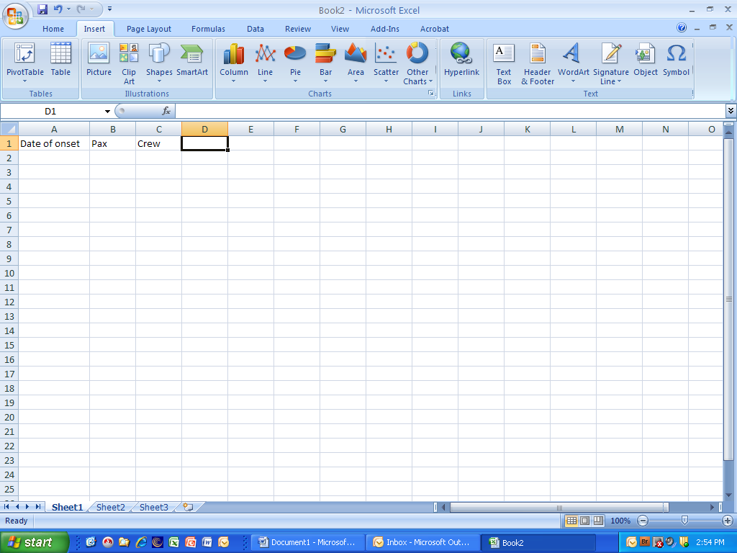

Step 2 – In the cells immediately below the Date of onset header, type in the dates of illness onset using any valid date format
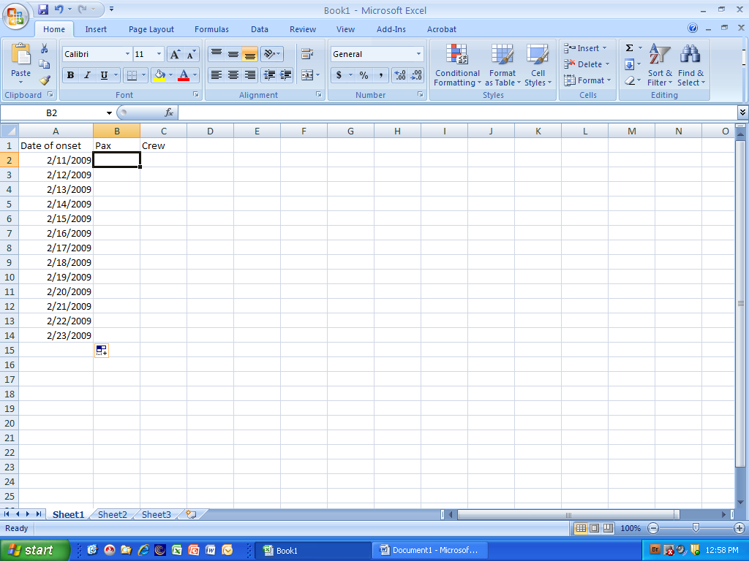

Step 3 – In the cells immediately below the Passenger or Pax column, enter the number of cases corresponding to each date of onset. If there are no cases for a particular date of onset, enter a zero (0).
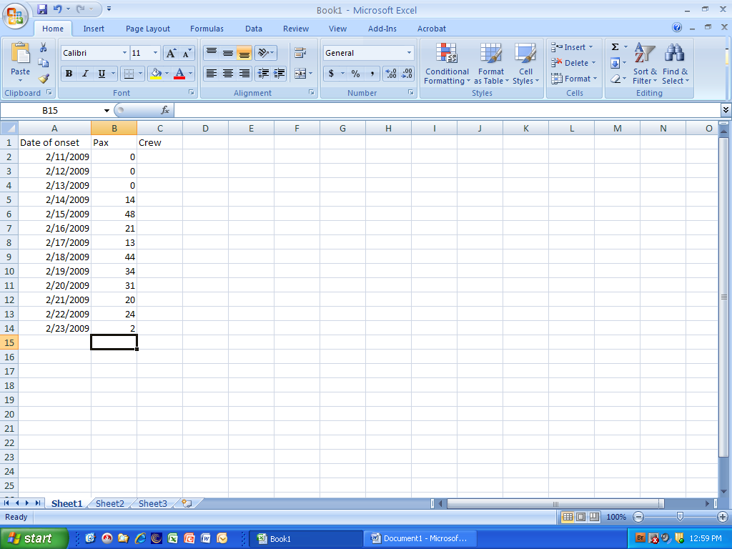

Step 4 – In the cells immediately below the Crew header, enter the total number of crew cases for each corresponding date of onset. If there are no cases for a particular date of onset, enter a zero (0).
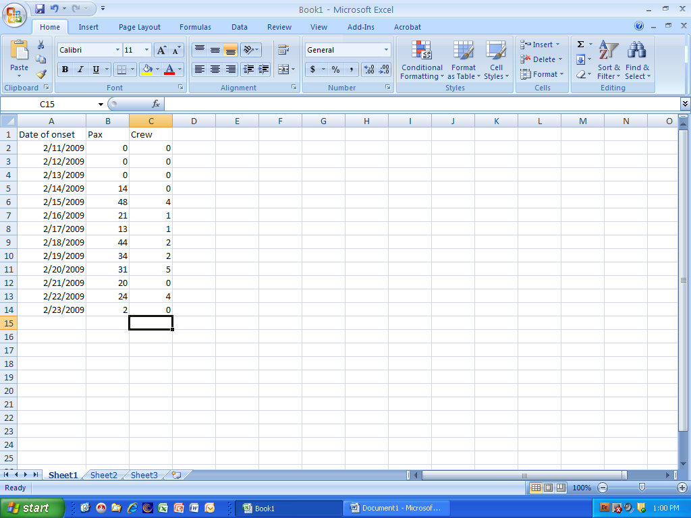

Step 5 – Using the mouse, press and hold the left mouse button and drag to highlight the passenger and crew case data (including the headers) as shown in the picture below
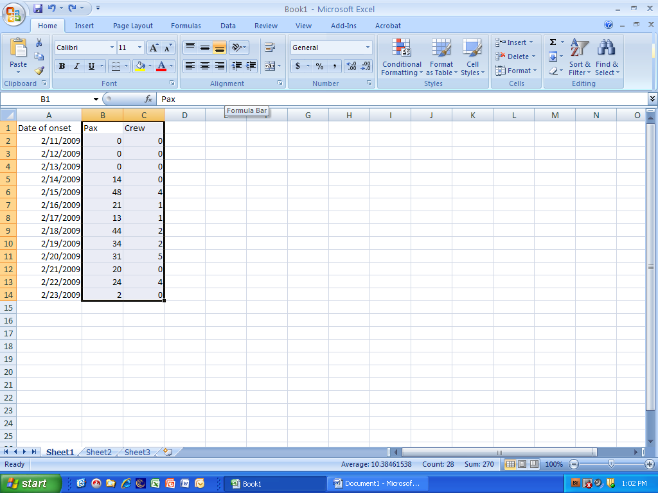

Step 6a – Select the Insert ribbon, then press and hold the Columns button to bring up the Columns submenu. Under 2-D column select the middle button for the two-dimensional chart option. [Note: Is not necessary to use 3-D chart options for epidemic curves as it makes reading the chart more difficult.]
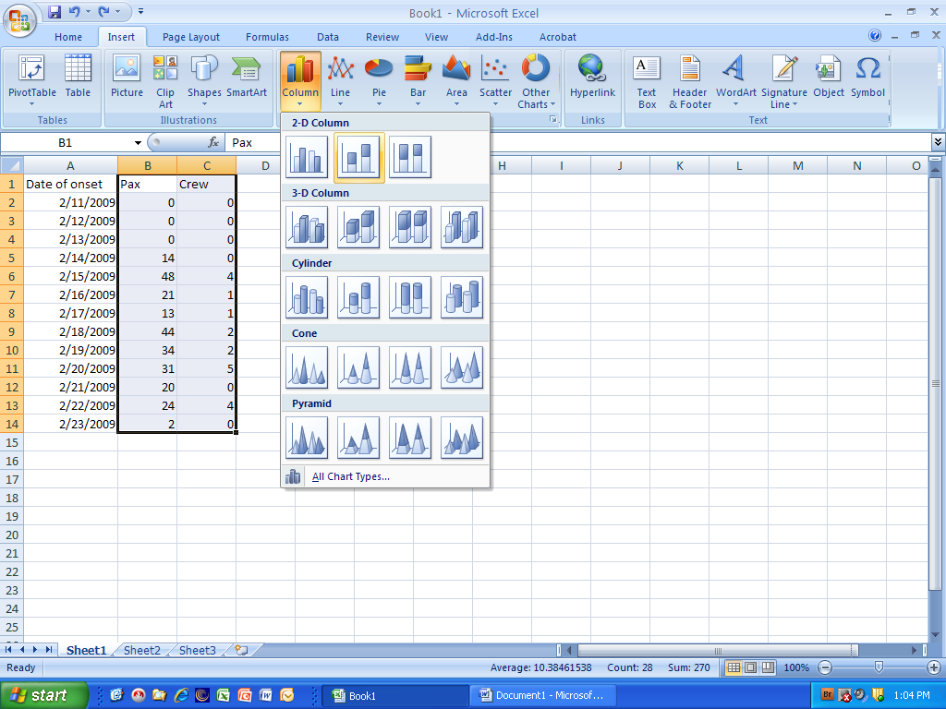

Step 6b – You should now see a chart similar to the one below. If not, select the “Undo” button (the blue arrow curved to the left next to the disk icon above Home) and repeat the last step.
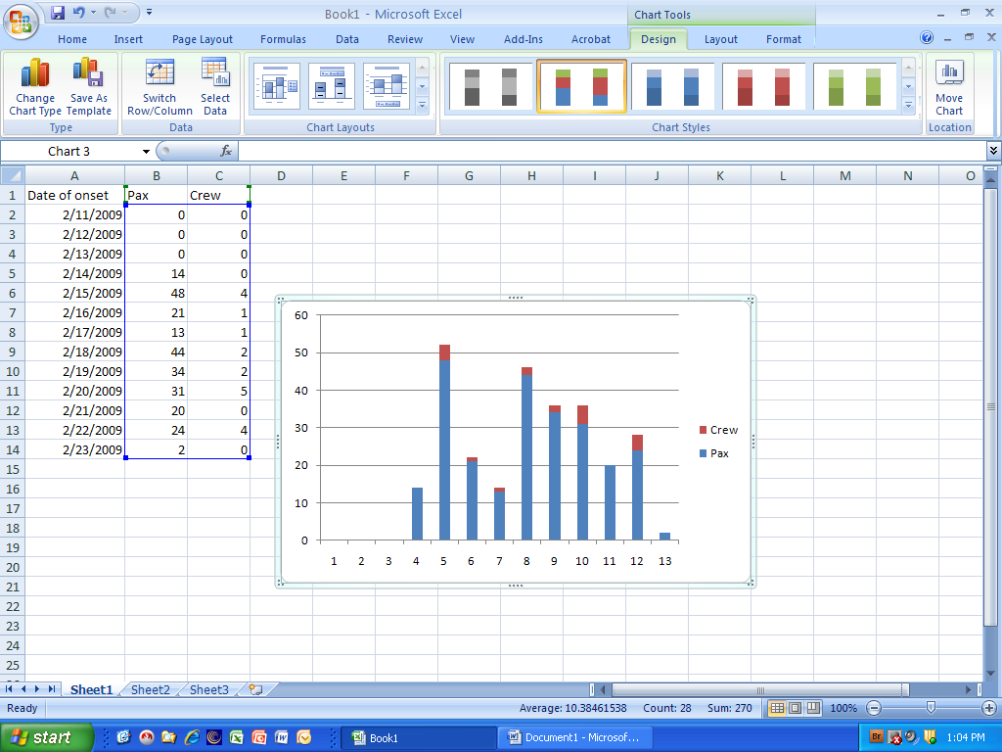

Step 7 – To change the X-axis (Category) labels, select the Design ribbon item, then press the Select data button to bring up the dialog box below. Under the Horizontal (Category) Axis Label area, press the Edit button
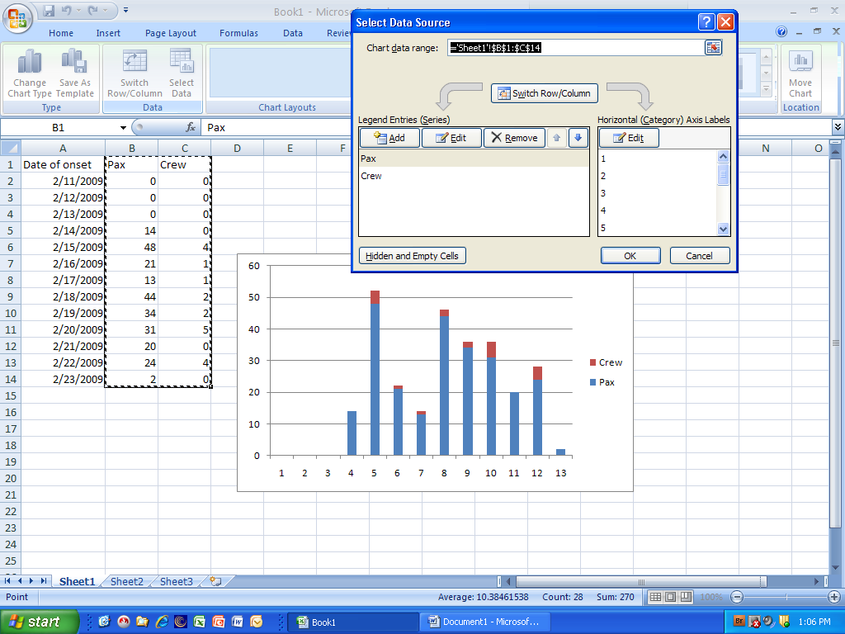

Step 8a – Select the small icon to the right of the Axis Label range box
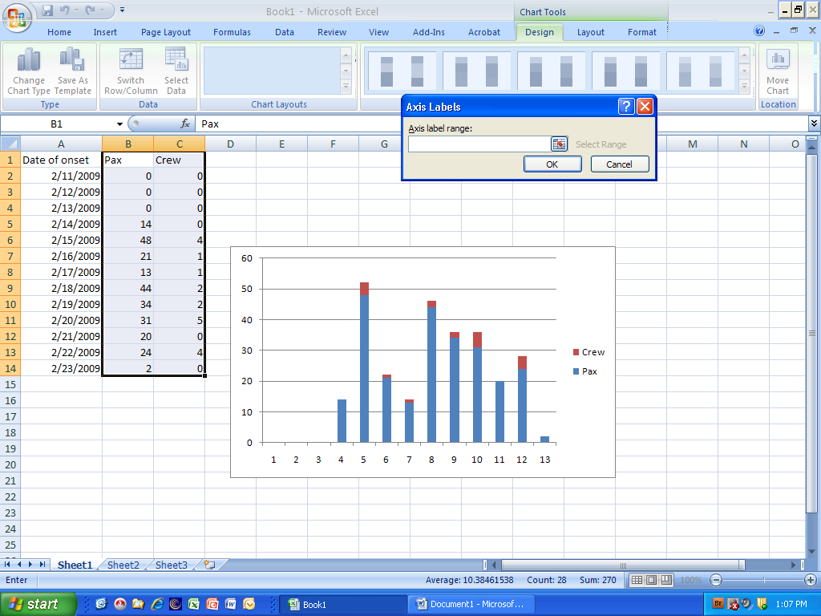

Step 8b – With the mouse, press and hold the left mouse button and highlight the Date of onset column, but do not include the column header.
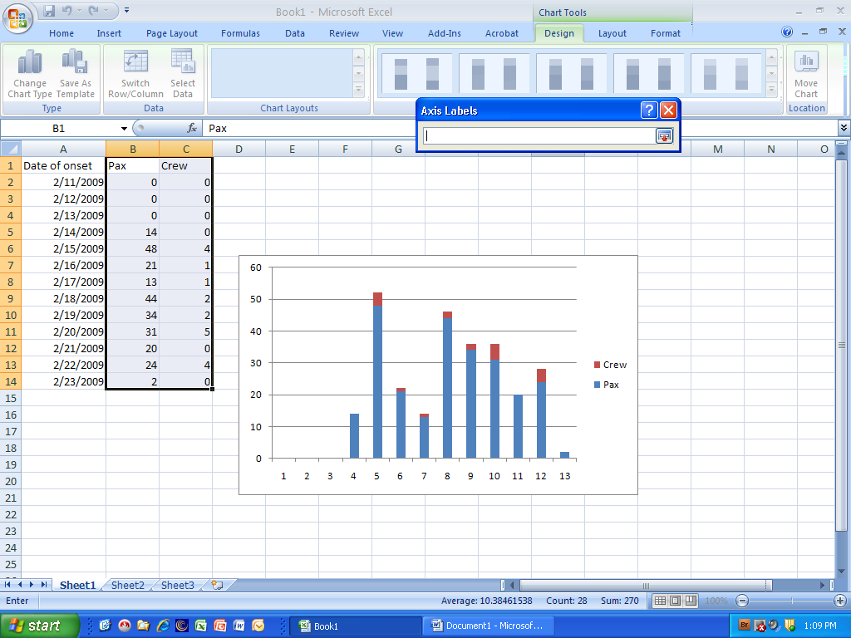

Step 8c – Your screen should look similar to the screen below. The dashed line around the date of onset range informs you of the dates selected. When ready, press the small spreadsheet icon to the right of the Axis label box.
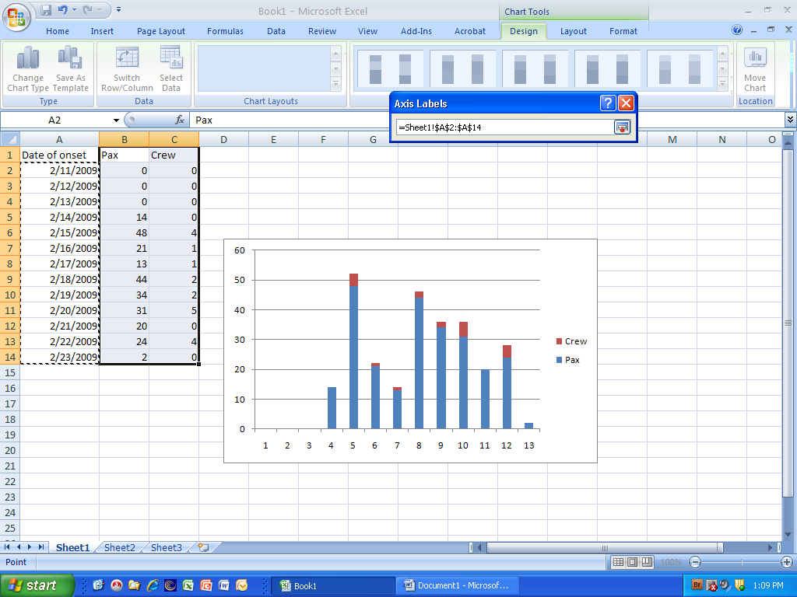

Step 8d – To complete the update of the dates of onset for the X-axis, press the OK button to commit the range. Your screen should resemble the one below.
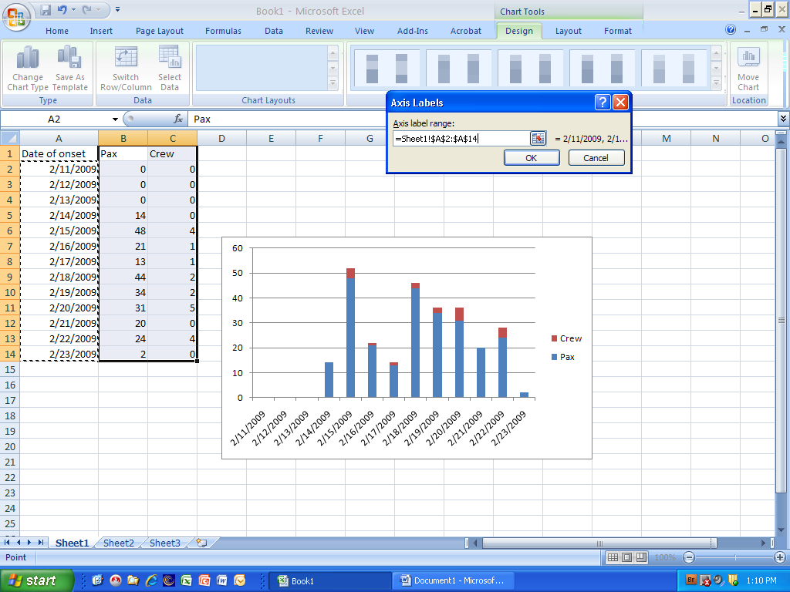

Step 9 – To remove the spaces between the bars, right-click on any bar. Then select the Format Data Series option at the bottom of the pop-up menu.
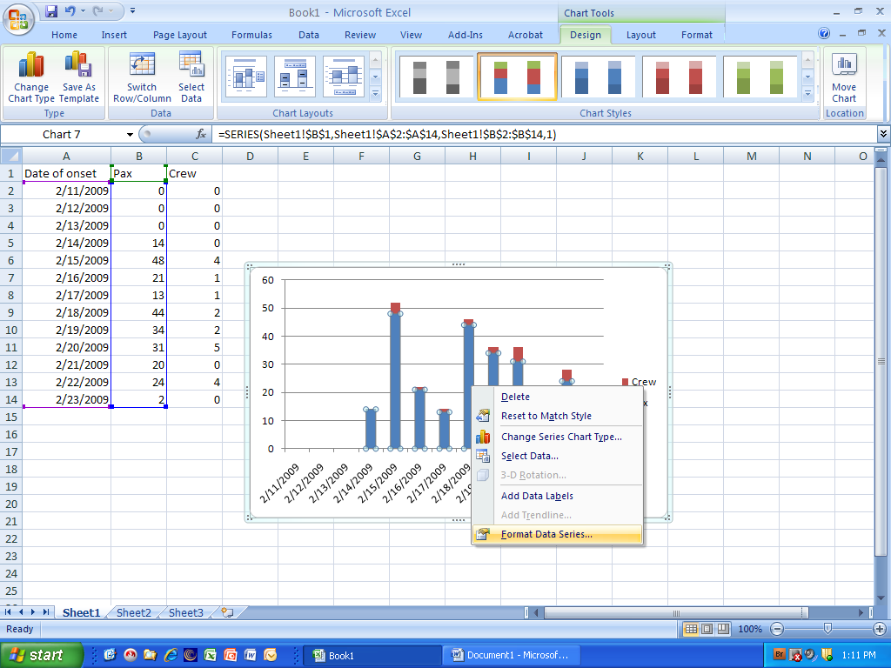

Step 10a – Using the slider under Gap Width, drag all the way to the left (No Gap). Note: this screen is also used to access series options such as fill and border color. To change the color and type of border around the bars, select Border Color and follow directions for color and type.
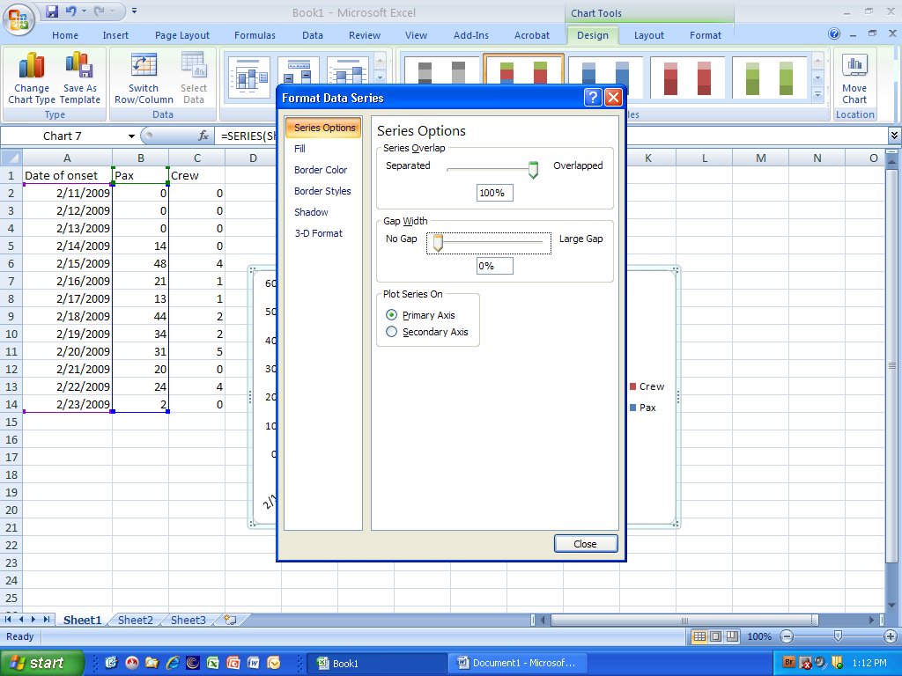

Step 10b – Your chart should look similar to the one in the picture below.
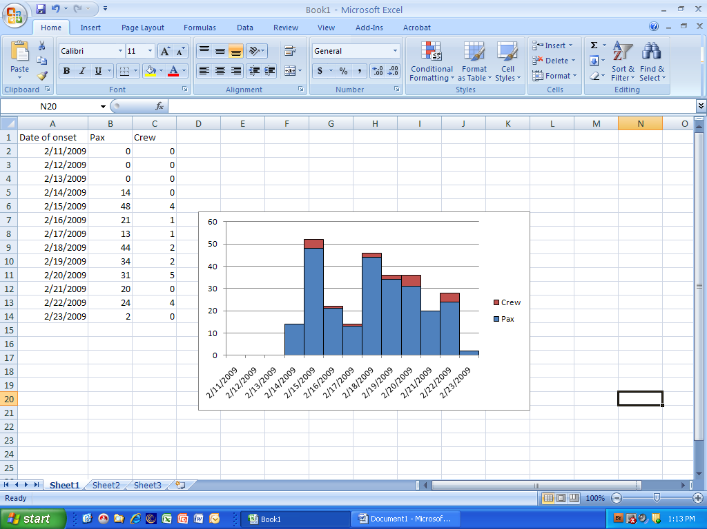

Step 11a – To add a title to the chart, under the Layout ribbon, select the Chart Title button, then the Above Chart option to place the title above the chart.
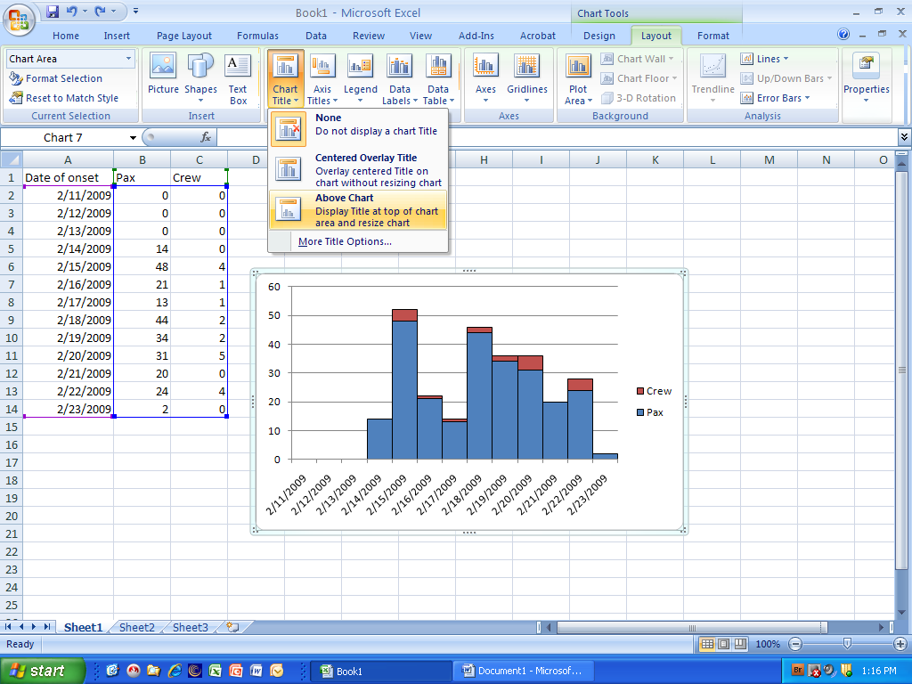

Step 11b – Enter an appropriate chart title
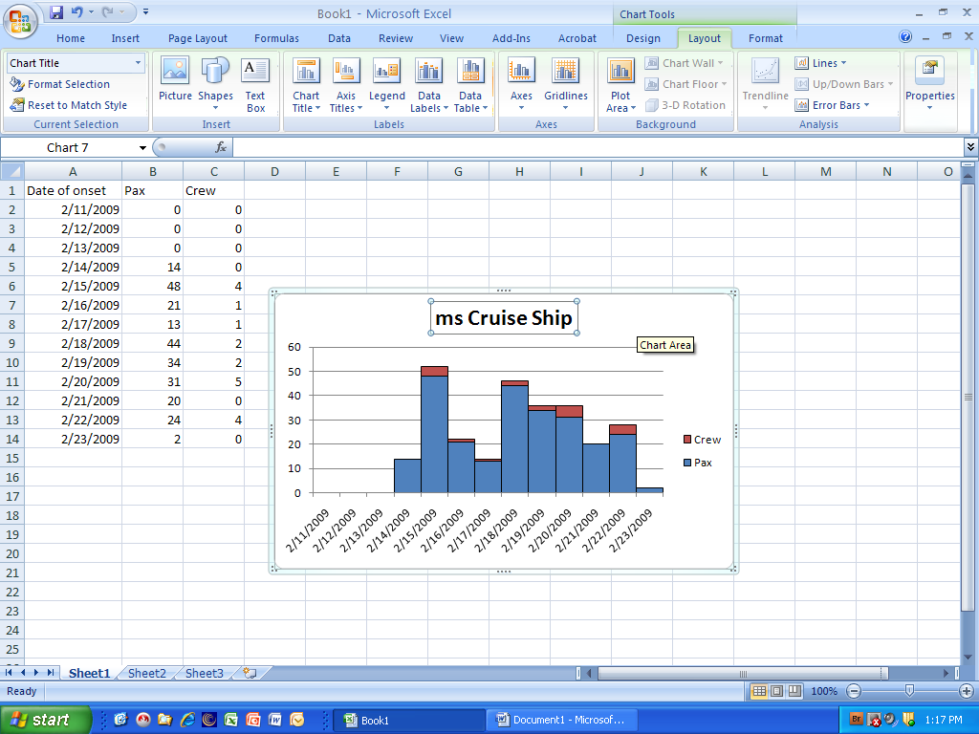

Step 12a – To enter the Horizontal Axis Title, under the Layout ribbon, select the Axis Titles >> Primary Horizontal Axis Title >> Title Below Axis option
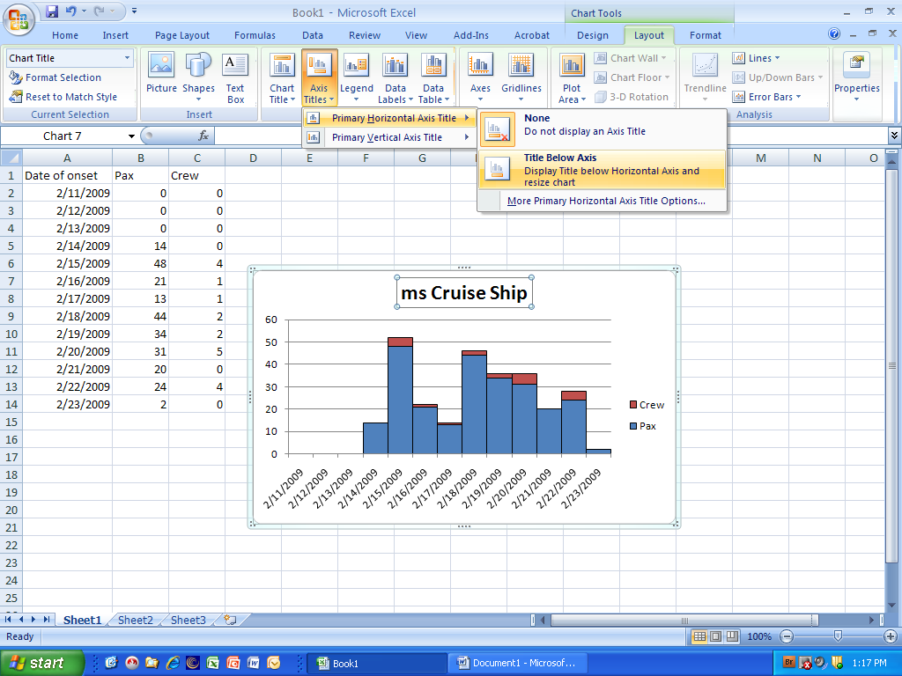

Step 12b – Enter an appropriate X-axis title such as “Date of illness onset”
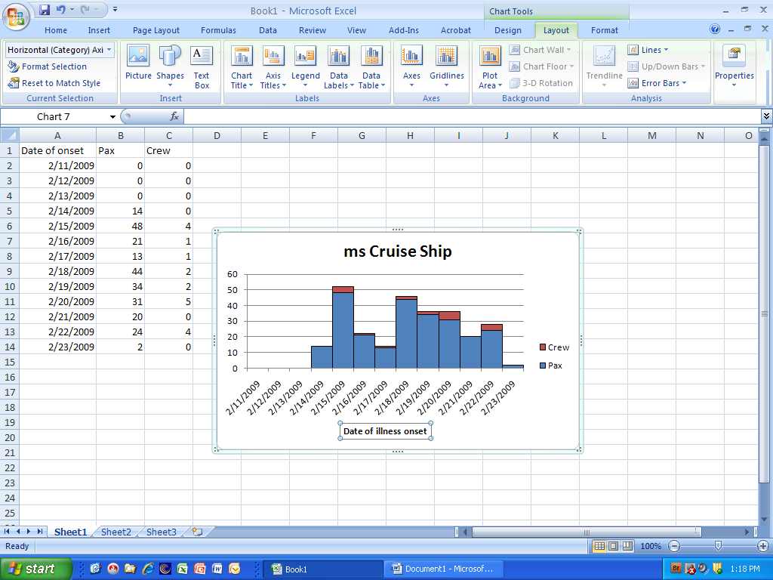

Step 13a - – To enter the Vertical Axis Title, under the Layout ribbon, select the Axis Titles >> Primary Vertical Axis Title >> Rotate Title option
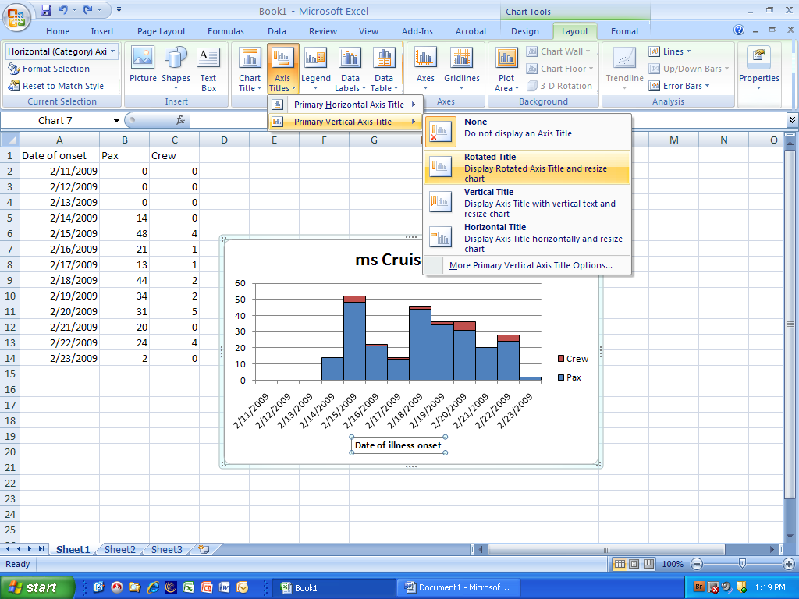

Step 13b – Enter an appropriate Y-axis title such as “Number of cases”
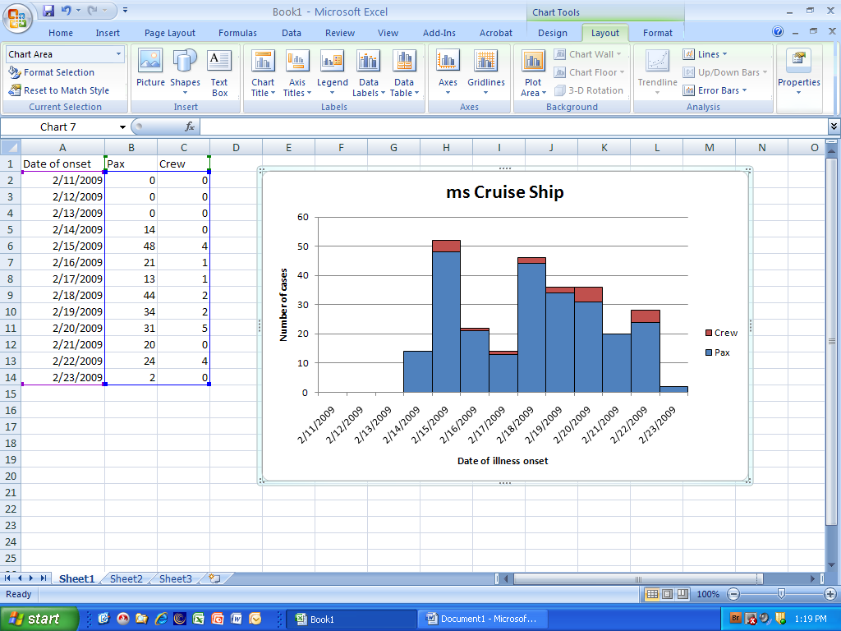

Step 14a (optional): To move the chart to a separate tab in the spreadsheet workbook, under the Design ribbon, select the Move Chart Location button on the far right side of the spreadsheet ribbon bar
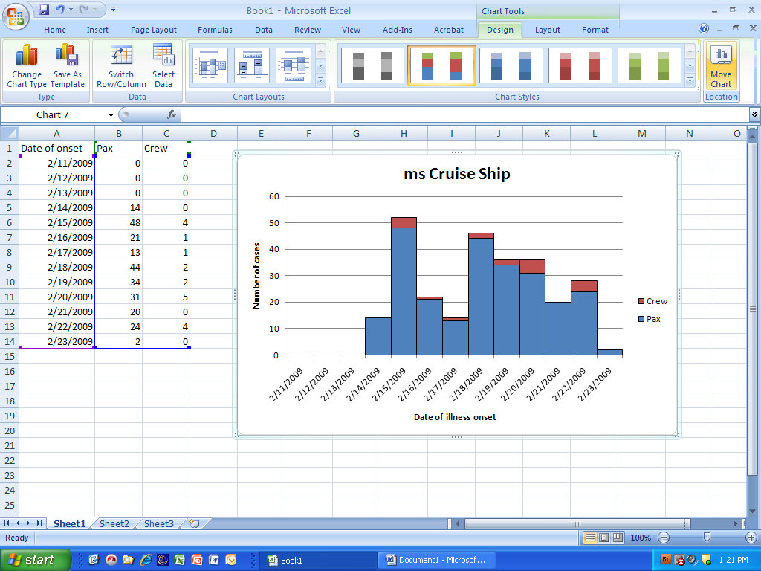

Step 14b (optional) – In the Move Chart dialog box, select the New sheet radio button and type in a name for the sheet, such as “Epicurve”, then select the OK button to close the dialog button.
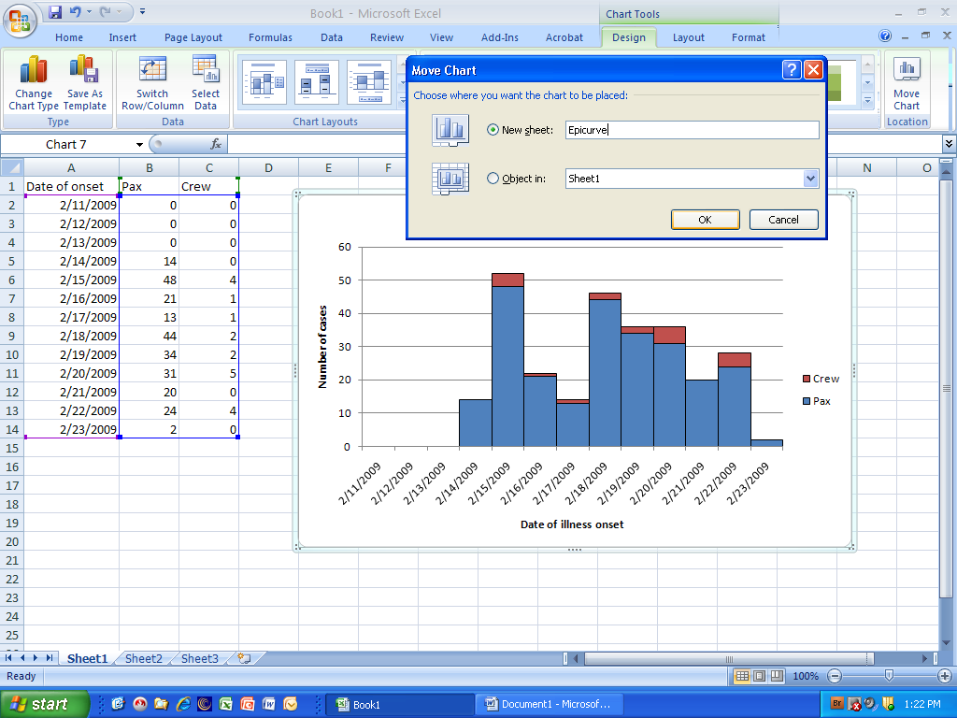

Step 15 (optional) – The complete epidemic curve should look similar to the chart in the picture below.
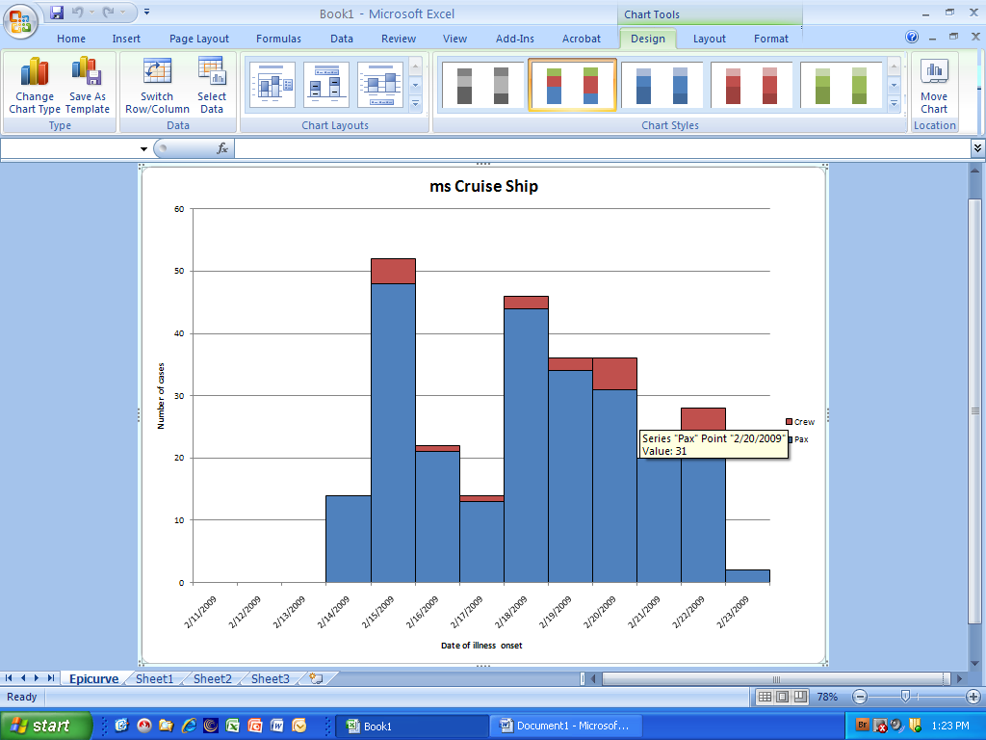

Step 16 – To save the chart and data, select the orange Microsoft button at the top left portion of the window, then select the Save As option, followed by the file format you wish to save the document in (most likely the Excel Workbook option). If you wish to send the document to someone who may have an earlier version of MS Excel, recommend selecting the Excel 97-2003 Workbook option.
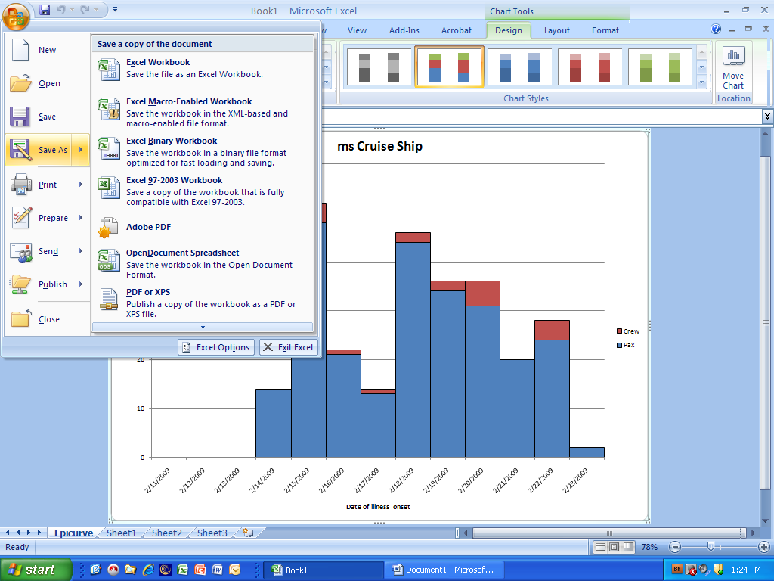

Step 17a (optional) – To create a, epicurve that has multiple time intervals in a day, insert a new column between the Date of onset and Pax column and label with an appropriate header (such as “am or pm”).
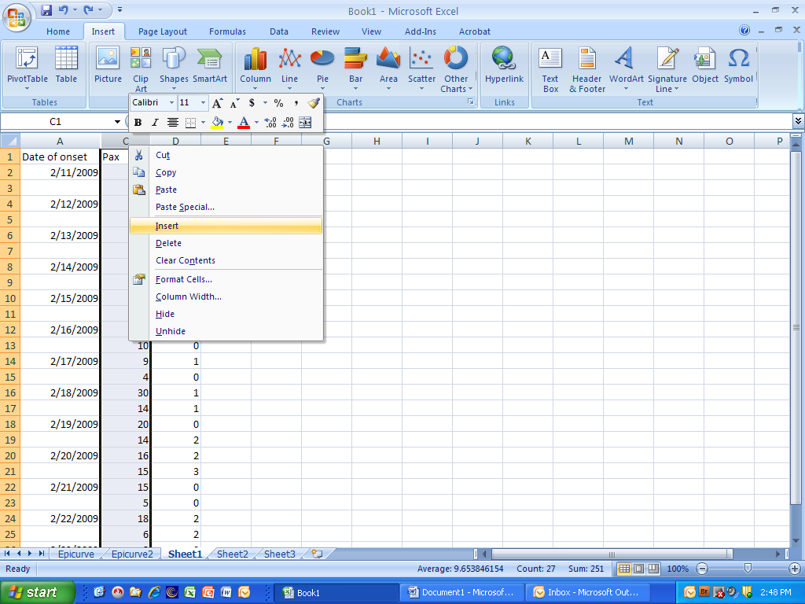

Step 17b (optional) - The method for creating the chart is the same, except in Step 8c, select both the Date of onset and the newly inserted column for time intervals (See picture below
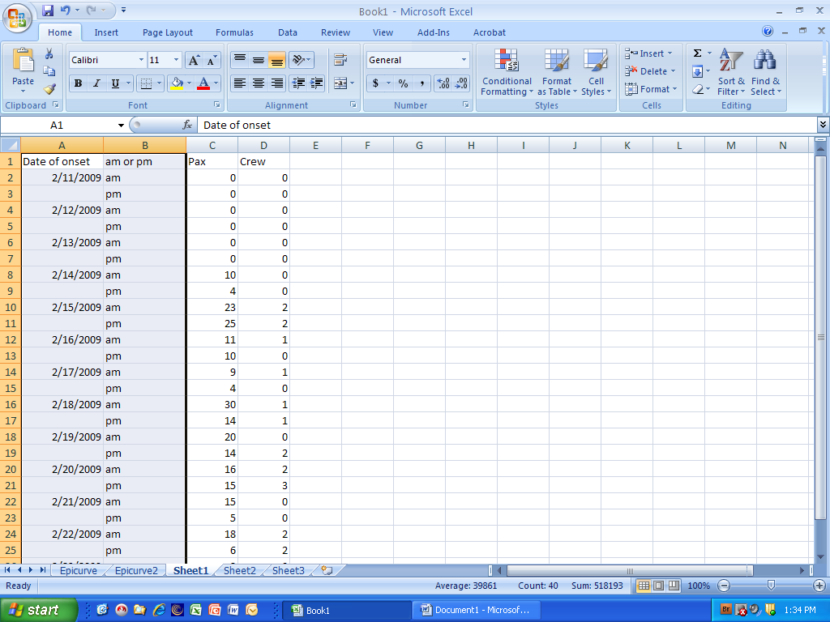

Step 17c – The newly created chart should resemble the picture below. Congratulations!
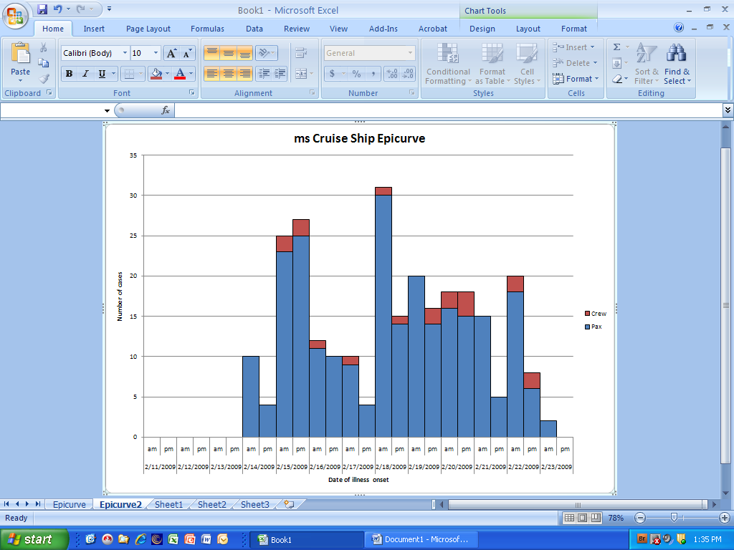
Microsoft Excel 2007 Copyright© Microsoft Corporation®

