
Share • Collaborate • Learn
Newsletter Date | Volume 1, Number 1
In This Issue  - Article name  - Spotlight on…  - Article name  Important Dates  Sept 8 – CoP Meeting  Oct 27 – CoP Event  Date - Event  Date - Event  Date - Event  Employment Opportunities  Title – Company - Link  Title – Company - Link  Title – Company – Link  Helpful Tools and Resources  Link to a Web page  Descriptive text that  motivates the reader  to click the link  Link to a Web page  Descriptive text that  motivates the reader  to click the link  Contact Us  someone@example.com | Newsletter Template  As your CoP begins maturing, you may want to develop a CoP newsletter for your domain. This template gives you a great start.  Delete and edit any section as needed. You can insert your own graphics or delete them entirely.  Spotlight on… [CoP member, project, tool]  Ut urna magna, consectetuer et, molestie vel, pulvinar vitae, magna. Praesent enim justo, consequat nec, auctor nec, ornare in, metus. Sed adipiscing. Donec mollis felis vel lorem. Phasellus iaculis eleifend nunc.Ut urna magna, consectetuer et, molestie vel, pulvinar vitae, magna. Praesent enim justo, consequat nec, auctor nec, ornare in, metus. Sed adipiscing. Donec mollis felis vel lorem. Phasellus iaculis eleifend nunc. Ut urna magna, consectetuer et, molestie vel, pulvinar vitae, magna. Praesent enim justo, consequat nec, auctor nec, ornare in, metus. Sed adipiscing. Donec mollis felis vel lorem. Phasellus iaculis eleifend nunc.  Ut urna magna, consectetuer et, molestie vel, pulvinar vitae, magna. Praesent enim justo, consequat nec, auctor nec, ornare in, metus. Sed adipiscing. Donec mollis felis vel lorem. Phasellus iaculis eleifend nunc.Ut urna magna, consectetuer et, molestie vel, pulvinar vitae, magna. Praesent enim justo, consequat nec, auctor nec, ornare in, metus. Sed adipiscing. Donec mollis felis vel lorem. Phasellus iaculis eleifend nunc.  Ut urna magna, consectetuer et, molestie vel, pulvinar vitae, magna. Praesent enim justo, consequat nec, auctor nec, ornare in, metus. Sed adipiscing. Donec mollis felis vel lorem. Phasellus iaculis eleifend nunc.  Ut urna magna, consectetuer et, molestie vel, pulvinar vitae, magna. Praesent enim justo, consequat nec, auctor nec, ornare in, metus. Sed adipiscing. Donec mollis felis vel lorem. Phasellus iaculis eleifend nunc.  Ut urna magna, consectetuer et, molestie vel, pulvinar vitae, magna. Praesent enim justo, consequat nec, auctor nec, ornare in, metus. Sed adipiscing. Donec mollis felis vel lorem. Phasellus iaculis eleifend nunc.  Ut urna magna, consectetuer et, molestie vel, pulvinar vitae, magna. Praesent enim justo, consequat nec, auctor nec, ornare in, metus. Sed adipiscing. Donec mollis felis vel lorem. Phasellus iaculis eleifend nunc.  Second article  Ut urna magna, consectetuer et, molestie vel, pulvinar vitae, magna. Praesent enim justo, consequat nec, auctor nec, ornare in, metus. Sed adipiscing. Donec mollis felis vel lorem. Phasellus iaculis eleifend nunc.  Ut urna magna, consectetuer et, molestie vel, pulvinar vitae, magna. Praesent enim justo, consequat nec, auctor nec, ornare in, metus. Sed adipiscing. Donec mollis felis vel lorem. Phasellus iaculis eleifend nunc. Ut urna magna, consectetuer et, molestie vel, pulvinar vitae, magna. Praesent enim justo, consequat nec, auctor nec, ornare in, metus. Sed adipiscing. Donec mollis felis vel lorem. Phasellus iaculis eleifend nunc.  Ut urna magna, consectetuer et, molestie vel, pulvinar vitae, magna. Praesent enim justo, consequat nec, auctor nec, ornare in, metus. Sed adipiscing. Donec mollis felis vel lorem. Phasellus iaculis eleifend nunc. Ut urna magna, consectetuer et, molestie vel, pulvinar vitae, magna. Praesent enim justo, consequat nec, auctor nec, ornare in, metus. Sed adipiscing. Donec mollis felis vel lorem. Phasellus iaculis eleifend nunc. Ut urna magna, consectetuer et, molestie vel, pulvinar vitae, magna. Praesent enim justo, consequat nec, auctor nec, ornare in, metus. Sed adipiscing. Donec mollis felis vel lorem. Phasellus iaculis eleifend nunc.  Ut urna magna, consectetuer et, molestie vel, pulvinar vitae, magna. Praesent enim justo, consequat nec, auctor nec, ornare in, metus. Sed adipiscing. Donec mollis felis vel lorem. Phasellus iaculis eleifend nunc.  Ut urna magna, consectetuer et, molestie vel, pulvinar vitae, magna. Praesent enim justo, consequat nec, auctor nec, ornare in, metus. Sed adipiscing. Donec mollis felis vel lorem. Phasellus iaculis eleifend nunc. Ut urna magna, consectetuer et, molestie vel, pulvinar vitae, magna. Praesent enim justo, consequat nec, auctor nec, ornare in, metus. Sed adipiscing. Donec mollis felis vel lorem. Phasellus iaculis eleifend nunc.
   | Enter text - Ut urna magna, consectetuer et, molestie vel, pulvinar vitae, magna. Praesent enim justo, consequat nec, auctor nec, ornare in, metus. Sed adipiscing. Donec mollis felis vel lorem. Phasellus iaculis eleifend nunc. Nam ultricies leo. Cum sociis natoque penatibus et magnis dis parturient montes, nascetur ridiculus mus. Sed dignissim blandit risus. Pellentesque dictum bibendum orci. Cras vel mi. Phasellus sapien nisl, tincidunt eu, congue ac, consectetuer eu, quam. Nunc risus libero, cursus nec, tempor et, condimentum fermentum, leo. Aenean dui. Duis leo nunc, pharetra rutrum, pellentesque sit amet, vulputate quis, diam. Nunc non magna. Ut rutrum vestibulum:
  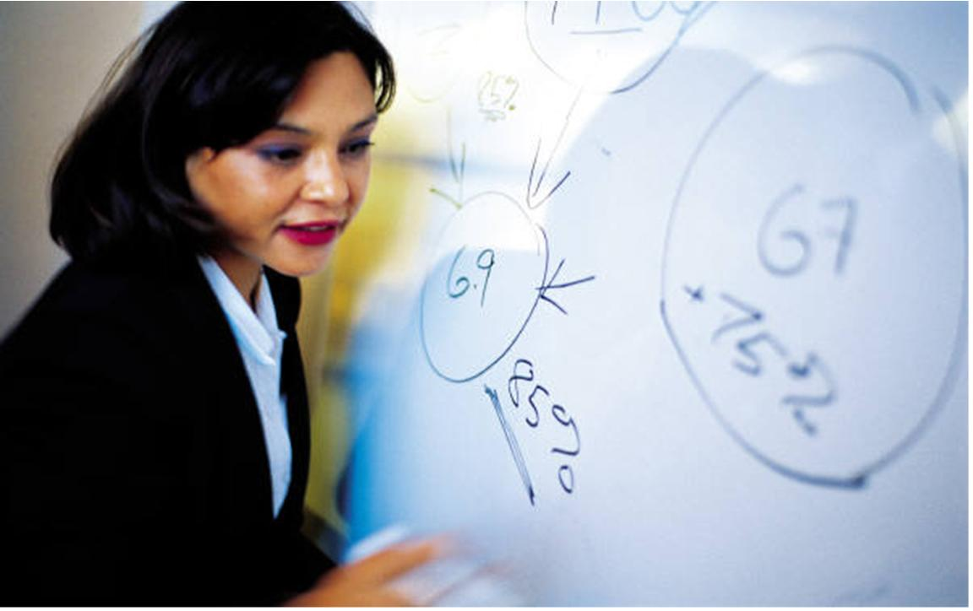 | Ut urna magna, consectetuer et, molestie vel, pulvinar vitae, magna. Praesent enim justo, consequat nec, auctor nec, ornare in, metus. Sed adipiscing. Donec mollis felis vel lorem. Phasellus iaculis eleifend nunc.

